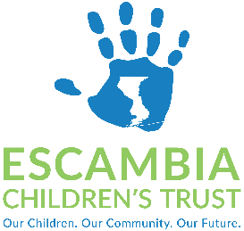
Policy Committee Meeting
November 2, 2022, at 1:00-2:00 PM
Open to the public at Brownsville Community Center
3200 W De Soto St, Pensacola, FL 32505

AGENDA

- Call to Order
- Roll Call
  - Policy Committee Members

    - Patty Hightower, Chair
    - David Peaden
    - Dr. Rex Northup
    - Stephanie White, Esq.
    - Tori Woods
    - Pastor Lonnie Wesley

  - ECT Staff/Advisor

    - Tammy Greer, Executive Director
    - Tammy Abrams, Director of Finance & Operations
    - Kimberly Krupa, PhD, Director of Programs & Performance
    - Meredith Bush, Esq., General Counsel – Clark Partington
    - Alma Ellis, Board Liaison & Administrative Specialist

- Approval of Agenda

- Policy Discussion Items
  - Authorized Expenditures for Refreshments and Meals
  - Emergency Funding
  - Cone of Silence
  - Bylaws – Elections and Committees
  - Scholarship Funding

- Adjournment

