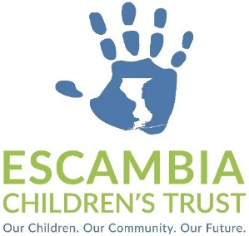
Personnel Committee Meeting
AGENDA

Wednesday, January 3, 2024, 2:00 PM
Open to the Public
1000 College Blvd. Bldg. 11
Pensacola, FL 32504

- Call to Order
- Approval of Agenda
- Executive Director Agreement Review
- Recommendation
- Public Comments*
- Adjournment

* The Escambia Children’s Trust welcomes comments from the public. Those who wish to address the Committee may do so at this time. Those addressing the Committee should complete a Public Comment Form prior to speaking and should state their full name and affiliation for the official record. In the interest of time, we ask that one person be designated to speak on behalf of a constituency and that all comments are limited to three (3) minutes. Thank you.

