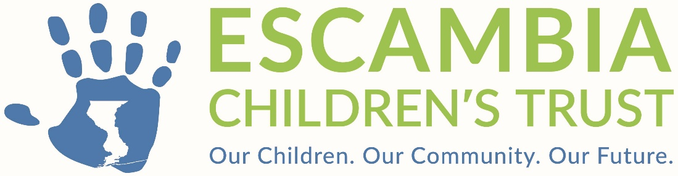

Escambia Children’s Trust

Board of Directors Meeting
January 14, 2025, at 5:30 p.m.
Ernie Lee Magaha Bldg., 221 Palafox Place, Pensacola, FL 32502

2025 ANNUAL MEETING AGENDA

- Call to Order (Tori Woods)
- Roll Call (Alma Ellis)
- Pledge of Allegiance (David Williams)
- Approval of Agenda (Tori Woods)
- Public Comment*
- Election of 2025 Officers (Tori Woods)
- Resolution 2025-02
Recommendation: The Executive Director recommends approval of
Resolution 2025-01 authorizing the replacement of board members to bank
accounts as signatory with an effective date of January 14, 2025.

- Adjournment (ten-minute recess to start January Board Meeting)

* The Escambia Children’s Trust allows any member of the public to speak regarding an item on the Agenda prior to Board action or regarding any related matter not on the agenda following the Legal Report near the end of the meeting. Anyone who wishes to address the Board is asked to complete a Public Comment Speaker Form. Each speaker is limited to three (3) minutes, unless otherwise determined by the Chairperson, to allow sufficient time for all speakers. Speakers shall refrain from abusive or profane remarks, disruptive outbursts, protests, or other conduct which interferes with the orderly conduct of the meeting. Upon completion of the public comment period, discussion is limited to Board members and questions raised by the Board.

