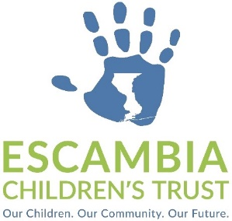
Personnel Committee Meeting
AGENDA

Tuesday, September 23, 2025 – 1:00 pm
Open to the Public
1000 College Blvd., Bldg. 26, 2nd floor
Pensacola, FL 32504

- Call to Order
- Approval of Agenda
- Approval of Minutes of the April 29, 2025, Personnel Committee Meeting
- Updated Job Description – Communications Manager
- Job Description – Contract / Finance Analyst
- Public Comments*
- Adjournment

Commissioner May, Chair
Kieth Leonard
Dr. Northup
Stephanie White
Tori Woods

* The Escambia Children’s Trust welcomes comments from the public. Those who wish to address the Committee may do so at this time. Those addressing the Committee should complete a Public Comment Form prior to speaking and should state their full name and affiliation for the official record. In the interest of time, we ask that one person be designated to speak on behalf of a constituency and that all comments are limited to three (3) minutes. Thank you.

