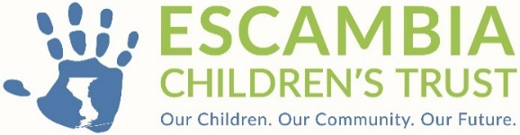

RESOLUTION 2025-04

A RESOLUTION OF THE ESCAMBIA CHILDREN'S TRUST AUTHORIZING THE EXECUTIVE DIRECTOR TO ENTER INTO AN AGREEMENT WITH LEGAL SERVICES OF NORTH FLORIDA, INC. TO OFFER LEGAL SERVICES TO ESCAMBIA COUNTY CHILDREN AND YOUTH

WHEREAS, the Escambia Children's Trust (the Trust), was created pursuant to §125.901, Florida Statutes, and

WHEREAS, the Escambia Children’s Trust, per §125.901, Florida Statutes, has within its power and functions to provide such other services for all children as the council determines are needed for the general welfare of the county, and

WHEREAS, a sole source application was submitted by Legal Services of North Florida, Inc. on November 1, 2022, and the Board of Directors approved year one and year two contracts with the provider. Based on results, the Program Committee recommends funding year three in the amount of $792,744 (Seven Hundred Ninety Two Thousand seven hundred forty four dollars and no cents).

AND, WHEREAS, the $792,744 cost is reasonable and within budget,

AND, WHEREAS the effective date of the contract with Legal Services of North Florida, Inc. for Legal Services is May 1, 2025.

NOW, THEREFORE, BE IT RESOLVED by the Escambia Children's Trust, that:

The Board of Directors of the Trust does hereby authorize the Executive Director to enter negotiations and a contract with Legal Services of North Florida, Inc. for Legal Services.
DULY ADOPTED in regular session, this 8th day of April A.D., 2025.

ESCAMBIA CHILDREN'S TRUST

By: _____________________________ ATTEST:_____________________________
Rex Northup M.D., Board Chair Lindsey Cannon, Executive Director

