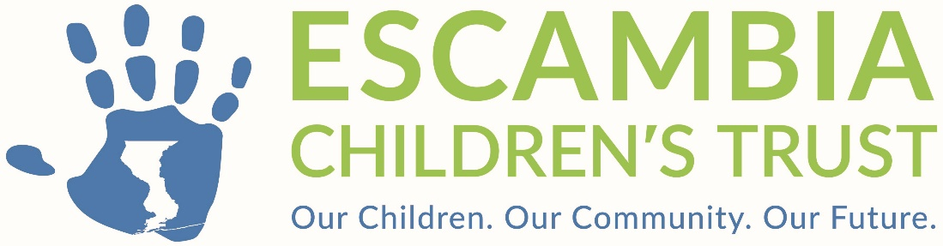

Escambia Children’s Trust

Board of Directors Meeting
April 14, 2026, at 9:00 a.m.

Ernie Lee Magaha Bldg.
221 Palafox Place
Pensacola, FL 32502

AGENDA

- Call to Order (Dr. Rex Northup)
- Roll Call (Alma Ellis)
- Pledge of Allegiance (David Williams)
- Approval of Agenda (Dr. Rex Northup)
- Approval of Minutes (Dr. Rex Northup)
Recommendation: Staff recommends the Board approve the Minutes of
the March 10, 2026, Regular Board Meeting, as presented.

- Treasurer’s Report (Tammy Abrams)
Financial Report – Month Ending February 28, 2026
Recommendation: The Finance and Operations Committee recommends the filing of the Financial Report for month ending February 28, 2026, as presented.

- Public Comments*
- Special Presentation – Ready Kids!

- Business
Programs
- Program Quality Assurance Policy and Supporting Plan / Procedure Deborah Ray)
  - Resolution 2026-13 The Policy and Bylaws Committee recommends approving Resolution 2026-13 authorizing the Executive Director to amend the ECT Policy Manual Part Two Funding Community Organizations, Creating a Subsection 2.8, Regarding Program Quality Assurance and Continuous Performance Improvement Policy.

- CMB Visions–CAREs Grant Withdrawal / Contract Termination (Lindsey Cannon)
  - Resolution 2026:14 The Program Committee recommends approval of Resolution 2026-14 authorizing the Executive Director to terminate the funding agreement with CMB Visions Unlimited, Inc., and to deobligate any remaining funds thereunder.

- Boys & Girls Club – Budget Amendment OST - Great Futures (Tammy Abrams)
- Boys & Girls Club – Budget Amendment Mental Health- Mind Time (Tammy Abrams)
- Legal Services North Florida Contract (Lindsey Cannon)
  - Resolution 2026:17 The Program Committee recommends approval of Resolution 2026-17 authorizing the Executive Director to extend the funding agreement with Legal Services of North Florida for two months through June 30, 2026.

Operations
- Policy Manual Update (Megan Fry / Sallie Neese)

  - Resolution 2026-15 The Policy and Bylaws Committee recommends approval of Resolution 2026-15 authorizing the Executive Director to amend the ECT Policy Manual Part 2, Funding Community Organizations and The Award of Funding to Community Organizations.

- Indirect Costs Policy (Lindsey Cannon)

  - Resolution 2026-16 The Policy and Bylaws Committee recommends approving Resolution 2026-16 creating a new subsection 1.8, regarding indirect costs.

- Legal Report (Megan Fry, Esq.)
- Adjournment
* The Escambia Children’s Trust allows any member of the public to speak regarding an item on the Agenda prior to Board action or regarding any related matter not on the agenda following the Legal Report near the end of the meeting. Anyone who wishes to address the Board is asked to complete a Public Comment Speaker Form. Each speaker is limited to three (3) minutes, unless otherwise determined by the Chairperson, to allow sufficient time for all speakers. Speakers shall refrain from abusive or profane remarks, disruptive outbursts, protests, or other conduct which interferes with the orderly conduct of the meeting. Upon completion of the public comment period, discussion is limited to Board members and questions raised by the Board.

